Irongray Community Newsletter – Spring 2025
For both new and established residents, we hope the following information is of use!
Contact Irongray Community Council - email: irongraycc@gmail.com or tel: 01387730318
Our website is: www.irongray-community-council.co.uk and find Irongray Parish on Facebook.
Irongray Community Council - who are we? Chair is Roy Hiddleston and Treasurer Andrew Middleton. Other serving Community Councillors are Gary Peacock and Derek Wallace. Jan Hogarth was duly reappointed along with Ken and Annabel McBride (latter two as Secretaries) and we welcome a new member to the Committee, Alan Robinson.
Would you like to get involved? The Community Council is always keen to recruit new members - a warm welcome awaits anyone willing to join. If interested and have 90 minutes to spare every other month, please speak to a member, tel 01387730318 or email: irongraycc@gmail.com
Your local Dumfries & Galloway Councillor email contacts are:
iain.howie@dumgal.gov.uk pauline.drysdale@dumgal.gov.uk john.young@dumgal.gov.uk
Irongray Community Council Chairman’s report – Spring 2025
Planned future meetings in ‘25 are: 28th May (AGM), 2nd July, 3rd Sept, 5th Nov. Held in the Hall at 7pm, agendas and minutes are posted on our noticeboards. Members of the community are welcome at all meetings.
Defibrillator: This unlocked cabinet is mounted in a prominent position on the external wall at the Shawhead Hall door, the unit is immediately accessible and automatically guides a user through the process, therefore simple to operate. Please remember it is immediately available for use by anyone in an emergency, but training can be arranged if required - it is very important we all feel able to use it if it should be needed.
Shawhead Play Park. The play equipment is again open, safe and cleaned. We thank D&G for this.
Planning Matters:
The Covenanters’ Monument on Skeoch Hill: Following the discovery of damage, the Irongray Community Trust propose organizing necessary repairs (and funding) to restore the monument in conjunction with the Scottish Covenanter Monument Association.
Barnsoul Caravan Park: We continue to closely monitor to any planning applications or intentions concerning this.
Concerns re a planning application: Regarding a proposed new build house (near the main junction in the village centre), we have been advised the application has been withdrawn.
Irongray Community Council Treasurer Report: We’ve received our annual grant of £4000 for 2025/26 from the Annandale and Nithsdale Community Benefit Company (which administers funds from the Harestanes windfarm). This ANCBC grant is paid over to the Irongray Community Trust to hold and disburse on behalf of the community. We always welcome suggestions for community projects to help fund. This financial support by ANCBC is much appreciated.
The current balance for the Community Council Account stands at £7961.02. Grants have been awarded to Shawhead WRI, and Shawhead Primary School’s Parent Teacher Association to support their activities. Projects pending include improvement to the Hall’s lighting and remedial work to the external rendering and reinstating the badly weathered information boards at Irongray Church.
The ceilidh in February was another success. Although ticket numbers were down on last time we still broke even. Our target is for income from the hall to cover all hall expenditure, thus enabling grants received to be allocated to community projects. There are still evenings free during the week for letting the hall so please come forward if you have any suggestions.
Shawhead Village Hall – Recently successfully hosting activities diverse as Xmas craft classes and gatherings, ceilidhs, rehearsal space, private social and sports lets and club nights, we’d remind everyone
our Hall exists to provide a venue and forum for community use. Refurbished in recent years, we are very keen to encourage increased use of this attractive facility and would remind all it is available for hire. So, for your next function, celebration or any booking enquiry, please email: irongraycc@gmail.com or call 01387730318.
Hall Let Rates – inclusive of heating and lighting
Clubs/Organisations within Irongray - £12 per hour. Outwith Irongray - £15 per hour
Concessionary rate - £10 per hour Private Lets - £15 per hour
In addition to being available for hire, we’d be delighted to hear from anyone interested in running a new group or activity. And remember – funding can be made available for beneficial community projects through our annual grant from ANCBC (Annandale & Nithsdale Community Benefit Company). Applications for this funding are invited for consideration – download a form from the Irongray website or email irongraycc@gmail.com
Hall – current programme:
Badminton Club,
Juniors: Tues, 6.45-7.30pm, cost £1. Upper primary and lower secondary years, all welcome
And very well done to Millie, who won her school area junior badminton competition and was runner up in the Regionals.
Seniors meet Tuesdays, 7.30 – 9pm. £2.50 per person. Contact Annabel 01387 730318.
Shawhead SWI: meets at the Hall the third Wednesday of each month, September to June, 7.30 - 9pm.
Our Women’s Rural Institute offers a varied, interesting range of speakers and demonstrators.
April’s meeting has Anne Mclaughlin doing a hands-on craft night. Open evening is held on 21 May and everyone is welcome with Jane Hogg presenting an informative store cupboard cookery demonstration.
September’s showcase has Lorraine Jackson doing a hands-on craft demonstration on brooches. October has Andrea Stewart talking about her wool shop “Woolies” in Dumfries.
Anyone can come along to our meetings, where you’ll be made very welcome!
For more information contact: Anne Mckinnon, tel 07784208797 or email: cardmckinnon@aol.com
We are sorry to report the Shawhead Baby and Toddlers Group has suspended activities.
However the Hall and the equipment is still available – is there someone out there who’d like to run the group? If so, please contact us soonest on: irongraycc@gmail.com
Can we remind all vehicle owners the parking area outside the Hall is private and for Hall users only, particularly when in use! We urge drivers to respect this.
Events:
Annual Spring Clean Litter Pick: The past few years has shown a marked decline in participation in this, normally a Sunday afternoon. Appreciating residents may be otherwise engaged on weekends and, as it is so important to keep our streets and roadsides clear of litter, we invite people to do their own litter picks - either on their own immediately adjacent routes or on regular strolls and dog walks.
Irongray Craft and Produce Show will return on 23rd August 2025 and hopes to follow the success of last year! Old favourites of garden, kitchen, craft and children's entries are accompanied this year with plant and seasonal sale tables. This community event offers a great social opportunity to meet, compete and enjoy delicious hospitality. Check the attached schedule and get planning your entry. See you there!
A February Ceilidh Hoolie, held in Shawhead Village Hall… proved a huge success with many residents and visitors of all ages. The Peddling Rovers provided fabulous live music and helpful direction for the ceilidh dances, keeping the floor filled from start to finish. And, if you were unfortunate enough to miss it, look out for another later on in the year. Huge thanks to the organisers and helpers!
Shawhead Primary School: Find out what’s going on in our school by visiting our school blog - ‘Shawhead Shout Out’! Access this by using Google to search 'Shawhead Shout Out' and you should see it as the first hit. Once you're on the home page, perhaps save as one of your favourites.? The best way to view is on a laptop, desktop or I-Pad. On your phone, best look at it in 'landscape' mode. Everything going on in the school is shown in our ‘This Week’s Update’.
Since the Christmas holidays, we’ve had a busy time! We made lanterns for the Burns Supper Parade in Dumfries, we have been reciting poems for Burns’ Day and we survived Storm Eowyn! We have been Scottish country dancing, learning about Scottish myths and legends and experiencing Computing Science and Art & Design lessons – delivered by CDHS secondary teachers working in our school! We’ve been very sporty throughout the past few months too, some pupils taking part in badminton competitions, lacrosse competitions and practicing for the Nithsdale cross country championships held on the 26th March. Also, we’ve taken part in ‘Ram Tam’ music where a specialist Gaelic music specialist comes in and work with us, teaching us some Gaelic and all about Scottish musical instruments. Based on what we’ve learned, we had a March performance. We all look forward to the holidays as it’s been a long term and are excited about the mornings and nights getting lighter and the days getting longer!
Irongray Parish Church news: The main change at Irongray, Lochrutton and Terregles Parish Church is that since 1st January 2025, we have been linked with St. Michael’s and South Parish Church in Dumfries. In practical terms, this means that Sunday services now begin at 9.45am rather than 10am. Worship normally lasts just under an hour, then we enjoy tea, coffee and refreshments afterwards.
Morning Worship takes place at Irongray on the 2nd and 4th Sundays of the month.
On the 1st and 3rd Sundays of the month worship is at Terregles Parish Church.
On any 5th Sunday we meet in Lochrutton Mission Hall in Lochfoot. All these services are at 9.45a.m.
You would be most welcome to join us on a Sunday morning.
On Palm Sunday (13th April) our service at Irongray Parish Church will include a dramatic reading of Jesus’ passion. (at 9.45a.m.)
On Good Friday (18th April) there’ll be a reflective service at Terregles Parish Church at 7p.m.
On Easter Day (20th April), Holy Communion will be celebrated at Terregles Parish Church at 9.45a.m.
In May, formal services of Holy Communion will be celebrated at Terregles Parish Church on Sunday 4th May and at Irongray Parish Church on Sunday 25th May.
Our Songs and Scones continue at Terregles Parish Church once a month on a Wednesday at 10.30a.m. These gatherings involve a short time of worship in the Church, with a ‘Thought for the Day’, followed by tea, coffee and scones in the Session Room. The next dates are Wednesday 2nd April, Wednesday 14th May and Wednesday 25th June.
Please look out for our Sponsored Walk and Afternoon Tea we hope to hold in August in Shawhead. Dates are yet to be confirmed, but it will be advertised on the noticeboards nearer the time.
As ever, I am here for everyone in Irongray parish, so if I can be of any help or you’d simply like a chat, feel free to contact me at the Manse. Gary Peacock Minister 730759.
Irongray Book Club – Meets monthly, every second Monday, 7pm and is always a good social evening unearthing great reads. new members are very welcome. For more details, email: b9eth@yahoo.com
Attention dog owners! Surrounded by farmland and animals, please do keep your dog under control and know where it is at all times. If you see anything of concern, please report it: call 101.
Dog Fouling - Sadly, we've had reports of this not only in the village but also in the school's grass play area! Toxocariasis is a condition which can cause blindness; children are at risk as they are more likely to come into contact with soil or sand containing faeces. We take the opportunity to remind owners that not picking up after their pets is not only antisocial, but illegal too!
www.irongray-community-council.co.uk is our website - we’d welcome an interested wizard to assist with this – please step forward if you can!
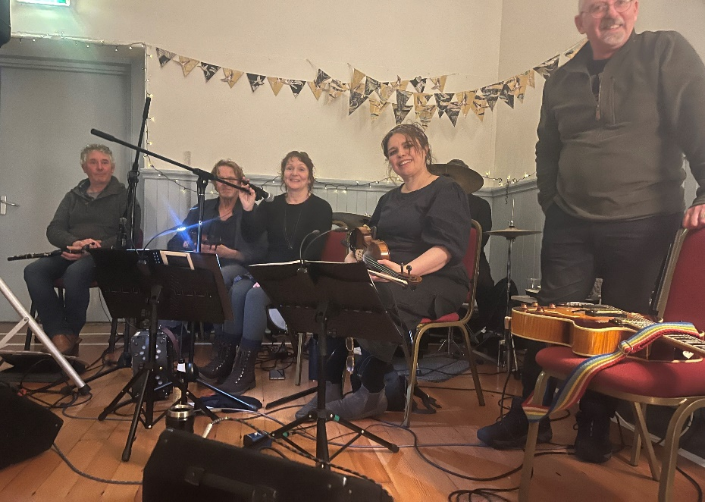

We hope this newsletter is of interest Please email us at: irongraycc@gmail.com with any constructive suggestions for inclusions or improvement!
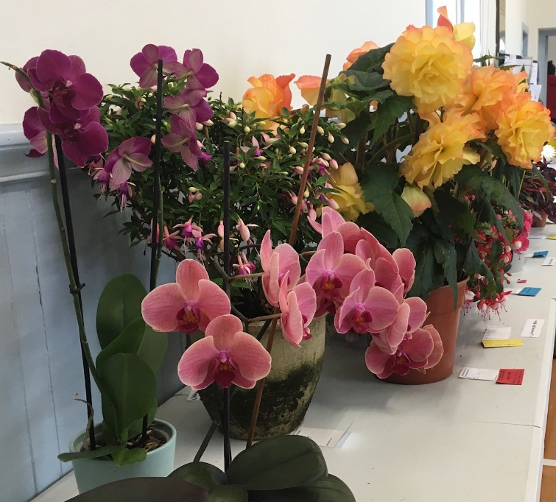
Thanks to the “Roving Pedlars “ for a great ceilidh

Printed with the kind co-operation of Solway Recycling Ltd: www.solwayrecycling.co.uk

