Irongray Community Newsletter – Winter 2024
For both new and established residents, we hope the following information is of use!
Contact Irongray Community Council - email: irongraycc@gmail.com or tel: 01387730318
Our website is: www.irongray-community-council.co.uk and find Irongray Parish on Facebook.
Irongray Community Council - who are we? Following the recent D&G Community Council Ordinary Elections in early October, we have returnees, new positions and a new face. We welcome Roy Hiddleston to his new position as Chair, Andrew Middleton continues as Treasurer, Gary Peacock and (new recruit) Derek Wallace. Due to an administrative error outwith our control, we need to have an additional election to re-appoint Jan Hogarth, Ken and Annabel McBride. This will be advertised in due course and will be open to other members of the community.
Our previous Chair Iain Mitchell and Vice-Chair Susan White both indicated their intentions to resign. As long term and much valued members of the Community Council, we extend our warm appreciation and thanks for their contributions.
Would you like to get involved? The Community Council remains keen to recruit new members - a warm welcome awaits anyone willing to join. If interested and have 90 minutes to spare every other month, please speak to a member, tel 01387730318 or email: irongraycc@gmail.com
Your local Dumfries & Galloway Councillor email contacts are:
iain.howie@dumgal.gov.uk pauline.drysdale@dumgal.gov.uk john.young@dumgal.gov.uk
D&G Council launches budget consultation 2025/26
Cuts in Dumfries and Galloway public funding means some services will be lost in 2025/2026. There is an open consultation where you can have your say on what services are essential - and everyone's opinion matters! We do ask all residents participate at: https://www.dumgal.gov.uk/budget by the closing date of 6th December 2024
Irongray Community Council Chairman’s report – Winter 2024
Planned future meetings are: 2nd Dec 2024, 8th January 2025, 5th March, 28th May(AGM), 2nd July, 3rd Sept, 5th Nov. All held in the Hall, 7.pm; agendas and minutes are posted on our noticeboards. Members of the community are welcome at all meetings.
Finance: Annandale and Nithsdale Community Benefit Company (which administers funds from the Harestanes windfarm) have increased our annual grant from £2000 to £4000; that sum was paid for the year to 31 August 2024 and we will shortly be applying for a similar grant for 2024/25. The ANCBC grant is paid over to the Irongray Community Trust to hold and disburse on behalf of the community: grants have been awarded to both Shawhead WRI and the Baby and Toddler group to support their activities. We always welcome suggestions for community projects to help fund. This support by ANCBC is much appreciated.
Defibrillator: This unlocked cabinet is mounted in a prominent position on the external wall at the Shawhead Hall door, the unit is immediately accessible and automatically guides a user through the process, therefore simple to operate. Please remember it is immediately available for use by anyone in an emergency, but training can be arranged if required - it is very important we all feel able to use it if it should be needed.
Shawhead Play Park. We are pleased to note this has reopened after several months of being out of action due to safety concerns. D&G Council replaced safety matting and have undertaken to clean the equipment, bringing it back into a useable condition. We thank them for this attention.
Planning Matters:
The Covenanters’ Monument on Skeoch Hill: It was brought our notice that the monument beside the communion stones has recently suffered severe damage, involving the cup and neck at the top of the monument breaking off, apparently due to rusting of the iron rod through the centre. After discussion, the Irongray Community Trust are proposing to seek to organize the necessary repairs (and funding) to restore the monument in conjunction with the Scottish Covenanter Monument Association.”
The Community Council continues to monitor closely any planning applications or intentions concerning the Barnsoul Caravan Park.
Irongray Community Council Treasurer Report: It was agreed by members of the Community Council to combine the Parish Hall and the Community Council bank accounts, to simplify things. From now on the newsletter will provide a report for the Community Council Bank Account only. Both the Craft and Produce Show and the September Hoolie produced a good profit boosting the Community Council Funds. Our target is for income from the hall to cover all hall expenditure, thus enabling grants received to be allocated to community projects. There are still evenings free during the week for letting the hall so please come forward if you have any suggestions.
The current balance for the Community Council Account stands at £8184.73
Shawhead Village Hall
The Hall exists to provide a venue and forum for community use. Refurbished in recent years, we are very keen to encourage increased use of this attractive facility and would remind all it is available for hire. So, for your next function, celebration or any booking enquiry, please email: irongraycc@gmail.com or call 01387730318.
Hall Let Rates – inclusive of heating and lighting
Clubs/Organisations within Irongray - £12 per hour. Outwith Irongray - £15 per hour
Concessionary rate - £10 per hour Private Lets - £15 per hour
In addition to being available for hire, we’d be delighted to hear from anyone interested in running a new group or activity. And remember – funding can be made available for beneficial community projects through our annual grant from ANCBC (Annandale & Nithsdale Community Benefit Company). Applications for this funding are invited for consideration – download a form from the Irongray website or email irongraycc@gmail.com
Hall – current programme:
Badminton Club,
Juniors: Tues, 6.45-7.30pm, cost £1. Upper primary and lower secondary years, all welcome.
Seniors meet Tuesdays, 7.30 – 9pm. £2.50 per person. Contact Annabel 01387 730318.
Women’s Rural Institute,
Meets at the Hall third Wednesday of each month, September - June, 7.30 - 9pm. Contact: cardmckinnon@aol.com
Shawhead Baby and Toddlers Group
Meets alternate Friday mornings (term time) 10.00 to 11.30am.The cost is £3 per family (includes a snack for the children). Contact Jillian on 07553756482. Or ‘Shawhead Toddler Group’ on Facebook.
Can we remind all vehicle owners the parking area outside the Hall is private and for Hall users only. We urge drivers to respect this.
Events:
Irongray Craft and Produce Show returned in August - revived, refreshed and very well attended. Old favourites of garden, kitchen, craft and children's entries, accompanied this year with plant and seasonal sale tables provided a new buzz and a big hit for all. This community event offers a great social opportunity to meet, compete, and enjoy delicious hospitality provided by Shawhead Rural. Many thanks go to all the organisers and helpers making the event such a success.
Show Prizewinners
Kellar Cup (Baking/Produce): 1st Jean McClelland, 2nd David White, 3rd Lorna Miller. Additional Prize (Small bottle of liqueur) – McBride,
Drummond Cup (Floral Art): 1st Jean McClelland, 2nd Barbara Kelly, 3rd Pat Bernard/Isobel Houston Additional Prize (Flowers in a cup and saucer)– Barbara Kelly,
Laurie Cup (Plants/Flowers): 1st Lorna Miller, 2nd Jill Hardy, 3rd Kelly, Chalmers, Bryden, Jefkins and McBurnie. Additional Prize (Foliage Pot Plant) – Vicky Jefkins,
Lockhart Cup (Fruit and Vegetables): 1st Ronnie Miller, 2nd Barbara Kelly, 3rd McBride.
Additional Prize (3 Tomatoes) – Ronnie Miller.
Keswick Cup (Handicraft): 1st Joan McBurnie, 2nd David White, 3rd Caroline Little.
Additional Prize (Handmade bookmark) – Joan McBurnie.
Best in Show: Joan McBurnie hand knitted scarf
Children’s Show prizewinners: Nursery & P1 – 1st Isla Hiddleston.
P2-P4 – 1st Devyn Craig, 2nd equal Zara Hiddleston and Ruari Hiddleston
P5-P7 – 1st Asa Wallace, 2nd Millie Young, 3rd Jackson Wallace
A September Harvest Hoolie held in Shawhead Village Hall… also proved a huge success with many residents and visitors of all ages. Shore Road provided fabulous live music, a mix of contemporary and ceilidh which kept the floor filled from start to finish. Huge thanks to the organisers.
Xmas Wreath-making Workshop - returns to the Hall on Saturday 7 Dec, 2-4pm.
All materials, foliage and instruction are provided in this fun, sociable afternoon. Cost is £25. And profits go to Doddie Aid MND charity. Limited places are available so, to book, email irongraycc@gmail.com
Shawhead Primary School: - Hello everyone, find out what’s going on in our school by visiting our school blog - ‘Shawhead Shout Out’! Access this by using Google to search 'Shawhead Shout Out' and you should see it as the first hit. Once on the home page, perhaps save as one of your favourites. Best way to view the site is on a laptop, desktop or I-Pad; on your phone it's best to view in 'landscape' mode. We've now added our new set of vision, values, aims and school motto - a big piece of work completed by all staff, pupils and parents last session.
Since the summer holidays, we have had a busy time! We have now achieved our Gold Sports Award - an amazing achievement for us as only a handful of schools in the region have the award at Gold level. Success in the garden too - the pumpkins we grew turned out really well and we carved them for Halloween. We also harvested and continue to harvest raspberries, onions and brussel sprouts! We've enjoyed two partnership events - a Halloween party at Lochrutton, and a ‘Charlotte’s Web’ themed day here at Shawhead.
This term is always busy with Christmas on the horizon. Our topic across both schools is ‘Fairtrade’ and we plan a Fairtrade coffee morning on Wed 4th December and would love community members to come and visit our school! More details to follow including leaflets through doors and posters displayed. We will then be working on our partnership Christmas Show held in Lochfoot Village Hall on Monday evening the 16th December.
Irongray Parish Church News: If you have not worshipped with us before, you would be most welcome at any of our services. Normal Sunday services begin at 10am and we have tea, coffee and refreshments after worship and a time to socialise with each other.
Morning Worship takes place at Irongray on the 2nd and 4th Sundays of the month at 10am.
On the 1st and 3rd Sundays of the month worship is at Terregles Parish Church.
On the 5th Sunday we meet in Lochrutton Mission Hall in Lochfoot.
Holy Communion will be celebrated at Irongray Parish Church, Sun 24th November at 10am.
Our Christmas Services follow our usual pattern:
Tuesday 24th December 7pm, Lessons and Carols in Lochrutton Mission Hall in Lochfoot.
Tuesday 24th December 11.30pm, Watchnight Service in Terregles Parish Church.
Wednesday 25th December 10am, Holy Communion in Irongray Parish Church.
Again this year we'll hold Carol Singing in Shawhead in conjunction with the Community Council on the evening of Sunday 15th December, beginning 6pm at the Primary School and walking round the village towards the Hall, where we shall enjoy mulled wine and mince pies. Hopefully, the weather will be kind, but if the weather is bad simply come to the Hall. Please join us.
May I take this opportunity to wish you every blessing of the season and assure you that I'm here for everyone in Irongray parish, so if I can be of any help or you'd simply like a chat, feel free to contact me at the Manse. Gary Peacock Minister 730759

Irongray Book Club – Meets monthly, every second Monday, 7pm, and is always a good social evening – new members are very welcome. For more details, please contact Pat on 07777 695802
Speed Limit reminder: Can we remind residents and their visitors of the mandatory 20mph speed limit now in place in the village.
Attention dog owners! Surrounded by farmland and animals, please do keep your dog under control and know where it is at all times. If you see anything of concern, please report it: call 101.
Dog Fouling - Sadly, we've had reports of this in the school's grass play area! Toxocariasis is a condition which can cause blindness; children are at risk as they are more likely to come into contact with soil or sand containing faeces. We take the opportunity to remind owners that not picking up after their pets is not only antisocial, but illegal too!
We’d hugely welcome an interested wizard to assist with our website – please step forward if you can!
Finally, Happy Xmas… and, talking of which, the 2025 Lower Nithsdale Red Squirrel Group calendar is both a perfect stocking filler, your new year organiser and, only £7.00!! This is a charity fundraiser to help red squirrel conservation so, please, order yours now – email: lorna.upperskeoch@gmail.com
We hope this newsletter is of interest Please email us at: irongraycc@gmail.com with any constructive suggestions for inclusions or improvement!
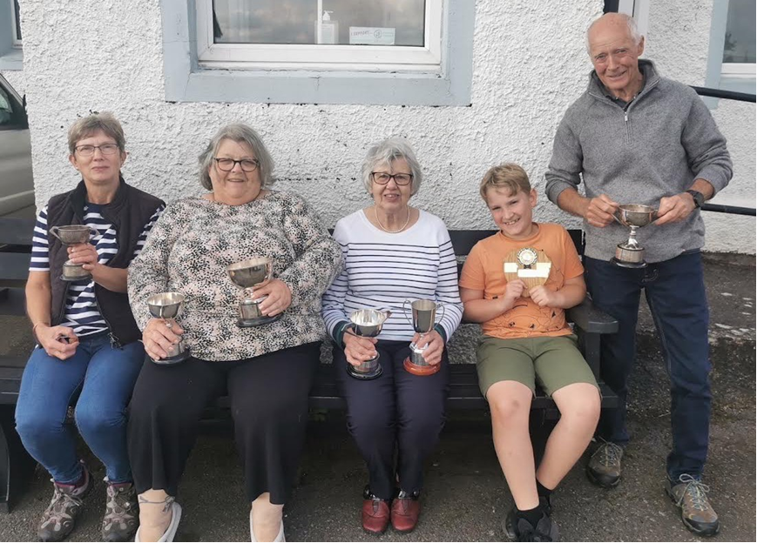
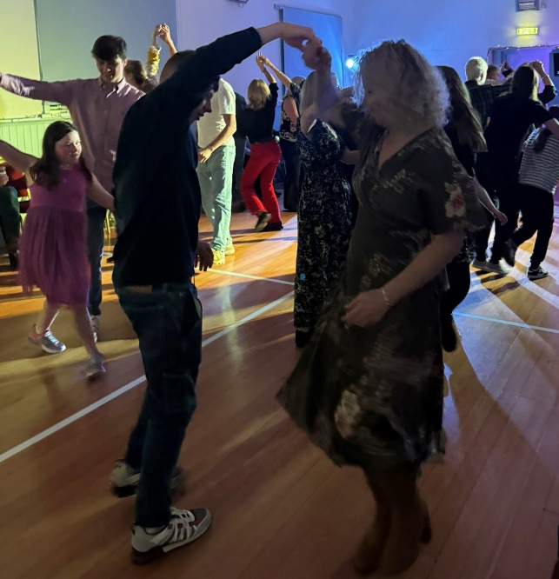

Printed with the kind co-operation of Solway Recycling Ltd: www.solwayrecycling.co.uk

