Irongray Community Newsletter – Spring 2022
For both new and established residents, we hope the following information is of use!
Our website is www.community-council.org.uk/irongray
Users can find Irongray Parish on Facebook too.
Your Community Council – who are we? Iain Mitchell (chair), Susan White (vice chair), Gary Peacock, Roy Hiddleston, Ruth Phoenix (treasurer), Karen Little, David Ball, Ken and Annabel McBride (joint secretaries: 01387 730318). Email contact is: irongraycc@gmail.com
Would you like to get involved? The Community Council would warmly welcome new members. If interested, and you have 90 minutes to spare every other month, please speak to a member or email: irongraycc@gmail.com

Your local Dumfries & Galloway Councillor email contacts are:
iain.howie@dumgal.gov.uk david.james@dumgal.gov.uk john.young@dumgal.gov.uk
Can we get in touch with you?
The pandemic demonstrated how difficult it is to contact people in our parish! If you are prepared to provide us your email address, it allows a means of communication for any important or relevant information. We would observe Data Protection guidelines and your details would never be used for any other purpose.
If happy to provide your email address, please contact us at: irongraycc@gmail.com
Irongray Community Council Chairman’s report 2021 – 22
Meetings: The Council met during 2021 in February, May and July on Zoom when it was unable to meet physically owing to Covid restrictions and the AGM was held as a virtual meeting in May, but meetings were held in the Hall in September and December; a Zoom meeting was also held in January 2022 but face to face meetings resumed in March.
Members and Officers: There were no changes to membership of the Council following the AGM when the Chairman, Vice-chairman and Treasurer were reappointed.
Finance: The accounts for the Community Council for the year to 31 March 2021 showed income of £3397.10 including the annual grant of £2000 from Annandale and Nithsdale Community Benefit Company (which administers funds from the Harestanes windfarm) which was paid over to the Irongray Community Trust to hold and disburse on behalf of the community. Projects authorised for funding from this in 2020-2021 included a grant of £500 to help set up the new Shawhead Baby and Toddler Group, litter notices for the playing field, repairs to the Hall floor and an allocation of £1285 towards the cost of revarnishing to be carried out in the summer. Their support to the community is much appreciated.
A separate Community Resilience Grant of £931 was also received to help get the Hall usable again after the Covid shutdown.
The accumulated balance is currently over £7,000 and any proposals for spending some of this for the benefit of the community are invited.
Parish Hall: Little use could be made of the Hall during the pandemic and most of the regular functions ceased, however following a deep clean in April it was possible to open the Hall to enable it to be used as a polling station for the election on 6 May and regular activities are happening once more. Some repairs were made to the floor of the main hall and its revarnishing is scheduled for 4 to 18 July - during which period the main hall will need to be out of action.
We are conscious that the pandemic has interrupted community life by preventing many of the regular activities in the Hall. The Community Council are anxious to see all groups resume their activities as well as for new groups and activities to begin. In particular, we do not wish the charges for use of the Hall to be a barrier to any community activities and would invite any group, or individual looking to organize a group to contact us for a discount or other financial support should that be the case.
Litter Pick: This could not be carried out in April 2021 as planned, but it is proposed that this should again take place Sunday 3rd April at 12 noon.
Craft and Produce show: This also could not be held in 2021 but will be reinstated this year on Saturday 20 August. More information is attached.
Defibrillator: This has now been connected to the electricity supply to warm the cabinet and help to prolong its battery life. The community is reminded that further training can be arranged if required; it is very important that all feel able to use it if it should be needed.
Road Traffic: Discussions have taken place about the route to be taken when extracting timber from the Deil’s Wood (near the playing field) but, after considering the alternatives, accessing the A75 via the village still seems to be the most practical, being by far the shortest, with assurances being given about frequency and timing of journeys.
If heavy vehicles from any particular company appear to be making frequent use of the road between Shawhead and the Routin’ Brig, please inform the Community Council with contact details and we will take the matter up with them. Discussions with the authorities are still ongoing as to the practicality of imposing a general weight restriction on that route.
Barnsoul Development: The Council have been in communication with the developers of the proposed leisure park to ascertain details of what is proposed and the implications for the community. A summary from Landal of its proposals is attached to this newsletter and a detailed presentation to the community in the Hall was held on 9 March 2022.
At the meeting strong views were expressed regarding the suggestion that the site might subsequently be enlarged to accommodate 220 units and a response to the planning committee has been lodged by the Community Council to record those views. It should also be noted that some of the views expressed are at variance with what is indicated in the summary attached.
Queen’s Jubilee. To support the Jubilee Year tree planting campaign (“the Queen’s Green Canopy”), three rowan trees (Sorbus Kashmiriana) were purchased and have been planted on the playing field with appropriate tree guards and a plaque.
Website: The development of the Council’s new website is now almost complete and it is hoped that this will be an effective platform for communication with and within the community.
Irongray Community Council Treasurer Report: Both accounts are healthily in the black.
Parish Hall Account balance - £3019.67
The Hall account is lower than it has been historically, because of lack of use during the Covid pandemic. The hall is now very much open for business again so if you have a meeting or celebration to organise, please consider using the hall.
The current monthly electricity charge is still £40 and the account is in credit so I will contact Scottish Power to get this transferred back into the hall account.
The annual fire equipment inspection has been done and the hall insurance is up to date.
The De-fib machine is ok. Battery is checked roughly every week.
Community Council Account. Balance £7426.63
The Council account is healthy; the total shown is after the latest ANCBC wind farm grant has been paid to the Community Trust account.
The account has remained static, mainly as there haven't been the usual community events during the pandemic. Here's hoping some of the regular community events we enjoy can take place again this year.
Remember, we are open to suggestions for expenditure on projects for the benefit of the community so if you have any ideas, please speak to a Committee Member or email: irongraycc@gmail.com
Shawhead Village Hall is all tidied up and back in use…
As Covid restrictions eased towards the end of last year, some regular groups returned to the Hall to enjoy their activities in the improved surrounds. The badminton club and WRI resumed meeting and we are delighted to welcome a new activity to the programme – the Shawhead Baby and Toddlers Group:
Runs in the village hall on the first and third Friday of each month (term time) from 10am - 11.30am. The group offers a range of toys and activities suitable for babies and toddlers to help encourage development of confidence and imagination in young children. Additionally, it allows parents, grandparents and care-givers the opportunity to socialise and support one another. Cost to attend is £3 per family (includes a snack for the children) and the group is always pleased to see new faces. For more details please follow ‘Shawhead Toddler Group’ on Facebook or contact Jillian Hiddleston on 07553756482.
The Group would like to thank Irongray Community Council for their support in setting up and Roy and Sharon Hiddleston from Solway Recycling for their sponsorship.
Very keen to encourage increased community use of the Hall, we would like to hear from anyone interested in running a new group or activity. And remember – funding can be made available for beneficial community projects through our annual grant from ANCBC (Annandale & Nithsdale Community Benefit Company). Applications for this funding are invited for consideration – forms are available to download from the Irongray website or, email us on irongraycc@gmail.com
Sadly for the Hall, two previously regular groups have not yet resumed - Scottish Country Dancing and Senior Citizens – but for anyone out there interested in re-establishing and helping run these, the Hall would be very pleased to welcome them. Email us on irongraycc@gmail.com
The Hall is available for let so, to find out more for your one-off event or regular meeting, please contact Selina on 07702 056727.
Shawhead Hall – current programme:
Badminton Club, meets Tuesdays, 7.30 – 9pm. £2.50 per person.
Contact Annabel 01387 730318. We’d be willing to set up a junior session (primary 5 upwards) so for any children keen to play, please contact us.
Women’s Rural Institute,
Meets third Wednesday of each month September - June, 7.30 - 9pm
Contact Carol for a syllabus: 01387 730286
Shawhead Baby and Toddlers Group
Meets on the first and third Friday of each month (term time) 10.00 to 11.30am.
The cost is £3 per family (includes a snack for the children).
Contact Jillian Hiddleston, 07553756482. Or follow ‘Shawhead Toddler Group’ on Facebook.
Irongray’s website… in the process of update, the new version is soon to launch.
D&G Council’s Community Resilience Fund allowed an opportunity to rebuild, refresh and make the Irongray site more user friendly, with a plan for increased future interconnectivity. For anyone out there with genuine interest in website design and content, any constructive suggestions for inclusion will be hugely welcomed - projects, articles, images or photographs (past and present) with local relevance. Email us at: irongraycc@gmail.com
Defibrillator - Just a reminder - this lifesaving device automatically guides a user through the process and therefore very simple to operate. The AED cabinet is mounted in a prominent position on the external wall at the Shawhead Hall door; the case is unlocked and immediately accessible if needed. Unsure how it works? Scroll down our Facebook page for a quick but instructive memory refresh.
The Defibrillator is now registered with the Hub. This means all local emergency response vehicles is aware of it and its location.

The Irongray Spring Litter Pick is back!
Residents are invited to join us on Sunday 3rd April. Meet 12noon at Shawhead Village Hall where we’ll organise routes, equipment and anything else you need to know for this useful and sociable event. And even if you cannot join us that day, we still urge everyone to keep our roadsides tidy and clean by the correct disposal of litter – please!

And so is the Irongray Craft and Produce Show!
So get growing, baking, art n’crafting ready for this year’s Show - planned this year for Saturday 20th August and held in Shawhead Village Hall when we’ll be showcasing the many skills of our residents of all ages! See the attached schedule for more detail to plan your entries.
Queen’s Jubilee Social Event, Shawhead Village Hall, Sat 4 June. More details to follow.

Shawhead Primary School: - update
We have been very busy in school this term whilst managing the restrictions placed on us by COVID-19 and are proud of staff and pupils for their resilience during such a difficult time and these are a few of our recent achievements:
Barcaple Outdoor Education Centre
Our older children recently attended Barcaple for an overnight outdoor education visit. They thoroughly enjoyed this experience and took part in various activities including: Climbing wall; Archery; Crate Climbing; and a Challenge Course. For a few of the children it was their first time staying away from home and not being with other family so quite an achievement for them!
Curling
During the Scottish Curling Championships our P5-7 children were invited along to the Ice Bowl to take part in a “Curlings Cool” Session. They were able to watch some of the Championship games but also had an opportunity to try out curling for themselves. It seems that quite a few of the children might take up the sport, inspired no doubt by our recent Winter Olympic success.

7th Eco-Schools Green Flag
We recently were very excited to learn that we had successfully achieved Eco-Schools Green Flag Award status for the 7th year!! This really is an excellent achievement and one we are very proud of – there are very few schools who have achieved this award. The Green Flag Awards are organised by the Eco-Schools Team from Keep Scotland Beautiful.
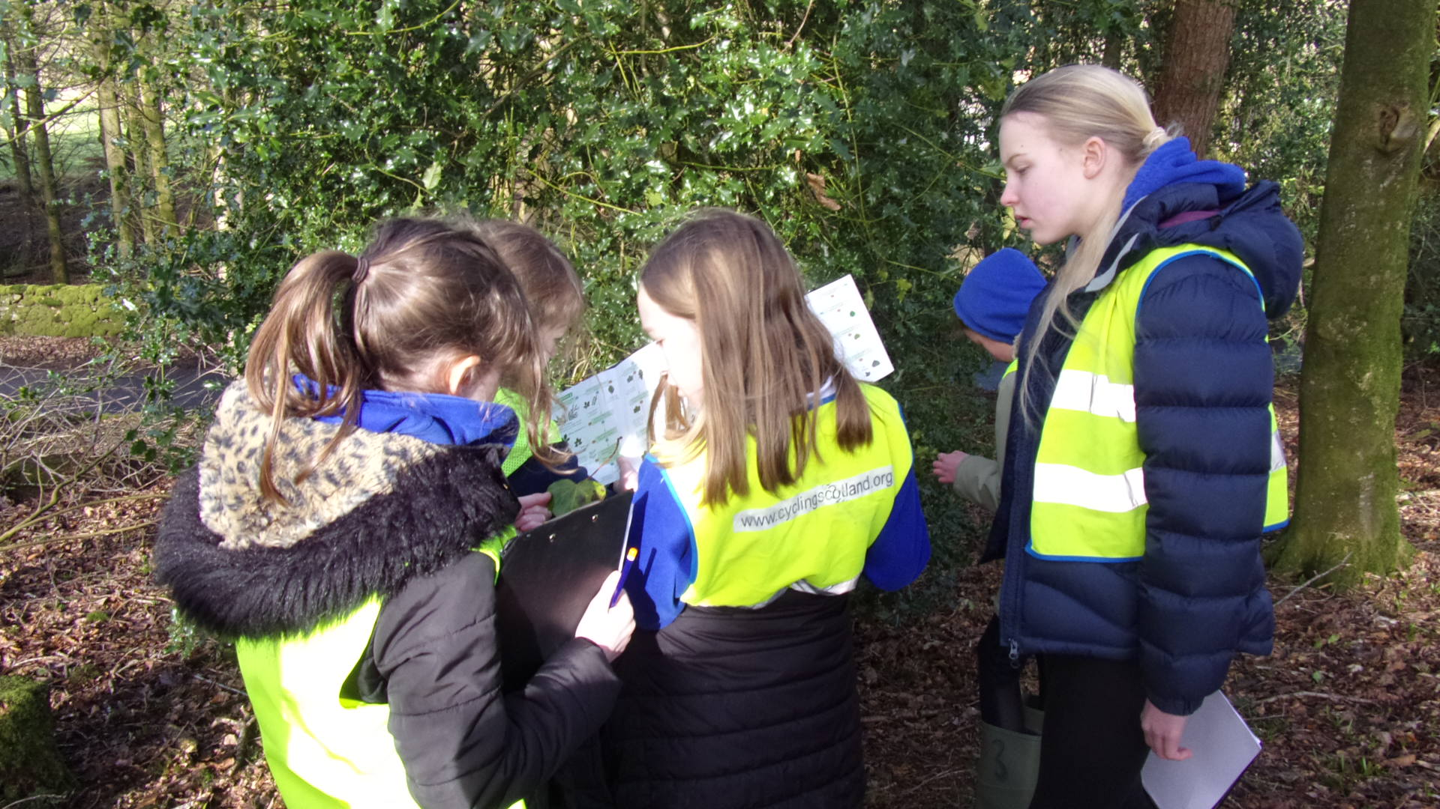
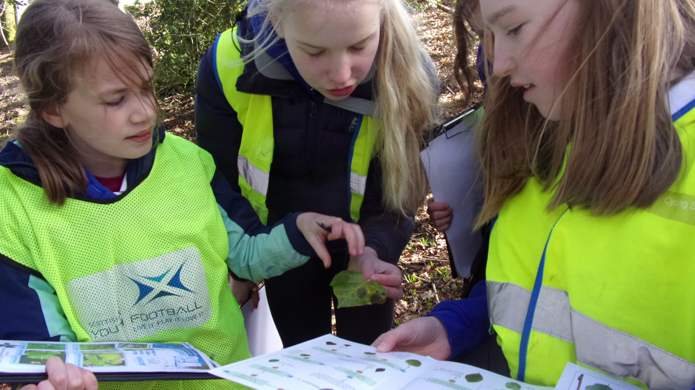

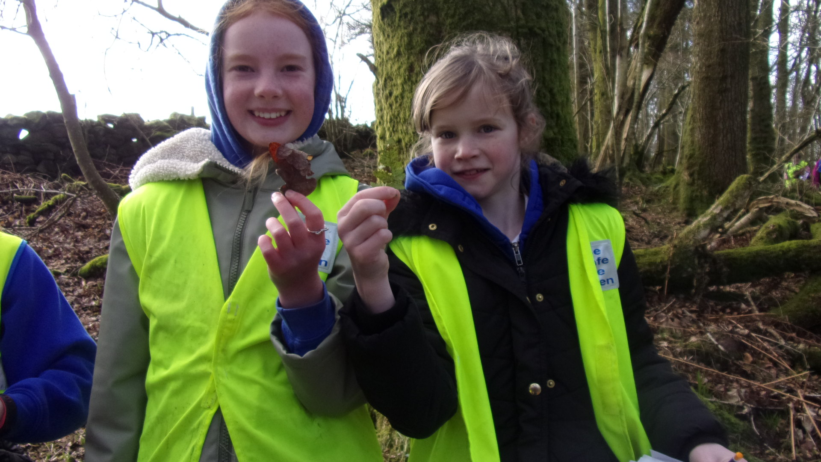
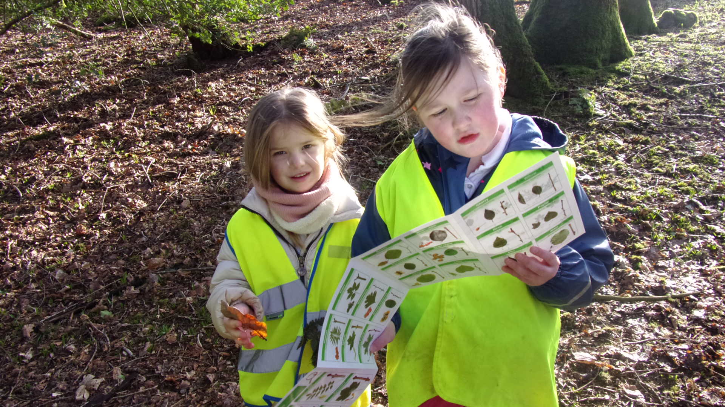

RSPB – Wild Challenge – Bronze Award
We have been busy completing other challenges in school recently and were delighted to receive a Bronze Award in the RSPB Wild Challenge. This challenge is all about helping wildlife, exploring nature and working through fun activities. There will be opportunities to progress to Silver and ultimately Gold awards through the RSPB in the future. The RSPB is the country’s largest nature conservation charity.

Unicef Uk – Rights Respecting School – Bronze Award
The UK Committee for UNICEF (UNICEF UK) promotes and protects children’s rights in the UK and internationally. They are a UK Charity, entirely funded by supporters. We are very proud to have recently been awarded a Bronze Award from the charity as a Rights Respecting School.

Irongray Parish Church News - a message from Gary, our Minister

As we start to enter Spring and leave Winter behind, I am pleased, like everyone else, that things are gradually beginning to open up once again, as we are hopefully moving out of the worst of the Covid 19 pandemic. At the moment we are still wearing masks in Church, but we hope that this may change after 21st March, when we assume the remaining restrictions will be lifted. Of course, I understand that many people will still wish to be cautious and if people wish to wear face coverings in Church and to sit at a reasonable distance that will be fine. The Church also hopes to re-start tea and coffee after the service when that is possible.

Services continue at Irongray on the 2nd and 4th Sundays of the month at 10am. On the 1st and 3rd Sundays of the month worship is at Terregles Parish Church. On the 5th Sunday we have been alternating between Irongray and Terregles and on 29th May 2022, the service will be in Irongray.

Our Easter services are as follows:
Palm Sunday (10th April) Irongray Parish Church 10am (with a dramatic reading of the Passion)
Good Friday (15th April) Terregles Parish Church 7pm.
Easter Day (17th April) Terregles Parish Church 10am.

Holy Communion will be celebrated at Terregles Parish Church on Sunday 1st May 2022 at 10a.m. and at Irongray Parish Church on Sunday 29th May 2022 at 10a.m.

You would be most welcome to attend any of the above services. We are also starting to think about our fundraising and social events now that we are allowed to meet up once again. Until 2019 it was our practice to take an empty shop in Dumfries and to use it to sell donated goods for Church funds. We are resuming that this year with a shop in Dumfries from 4th - 19th April at Burns Statue Square and if you have any clothes, crockery, gifts for the tombola, bric-à-brac or other items that you're looking to get rid of we would be happy to hear from you. Shirley Parker one of our elders is co-ordinating the shop and her telephone number is 01387 720732 if you would like more information. We also hope to resume holding social events, such as our Big Breakfast later in the year and these will be publicised locally on the village noticeboards.

I'd like to thank all those who have supported the Church during the past two years and to say that as minister of the parish, I am here for everyone in Irongray, so if I can be of any help or you'd simply like a chat, feel free to contact me at the Manse.
Gary Peacock 730759

Cairn Valley Community Transport: Shawhead - Castle Douglas service
This minibus runs every second Thursday through Shawhead. During March and April 2022 catch it on 17th and 31st March, 14th and 28th April, continuing every second Thursday thereafter. Social distancing is no longer in place so it is back to full capacity, though facemasks are currently still required. Intending passengers no longer need to book, but it's always handy if the driver knows in advance who to look out for so, a phone call preferably a couple of days ahead, is always helpful! Contact: Geoff (Secretary, CVCT) on 01848 330821 or 07702 915071 or email: geoff.creamer@outlook.com
The Thursday timetable is as before – departs Moniaive 11.15am, stopping at Kirkland, Wallaceton, Dunscore, Newtonairds and Shawhead at 11.45am; the return trip leaves Castle Douglas 15.05pm.

Irongray Book Club is back! Meeting now at 7pm on the FIRST Monday of each month. This is a great way to discover both new and old titles and is always a good social evening – new members are very welcome. For more details, please contact Pat on 07777 695802
Security: Your council meetings are regularly attended by a Police Scotland community officer who reports on local issues. Normally, the officer is available to meet with any community group, by arrangement, to advise on sensible steps to help safeguard person or property. A council member can provide contact details.
Speed Limit reminder: Can we remind residents and their visitors of the mandatory speed limits in place, particularly in the village. Young children live here and although most drivers are responsible, a few are not. For genuine concerns regarding speeding vehicles, please contact the police on 101 with registration number details.

We are fond of our Red Squirrels here…
And the volunteers of the LOWER NITHSDALE RED SQUIRREL GROUP have worked hard over the last year in conjunction with local estates and Saving Scotland’s Red Squirrels (SSRS) and have been particularly active in the Cairn and Old Water Valleys. We are lucky to still have a population of red squirrels, although reduced, but hope that our work with the removal of grey squirrels will help to build up the red squirrel population again.
In the past, we have worked in parallel and been supported by SSRS, but their current project finishes at the end of March. Whilst SSRS will have a presence in this area, it will be much reduced. In addition, we will not be receiving financial support and accordingly we will have to do our own fundraising. Given the strength of our group and the commitment of our volunteers, we are optimistic for the future. However, additional support from the local community is always welcome and if you are interested in volunteering, whether it be in fundraising, IT work, education or squirrel control, please get in contact with Andrew Middleton Mobile 07936942137
Attention dog owners!
Surrounded by farmland and animals, please do keep your dog under control and know where it is at all times. If you see anything of concern, please report it by calling 101.
Dog Fouling - Also, we take the opportunity to remind owners that not picking up after their pets is not only antisocial, but illegal too!
Please be a responsible owner, keep our environment clean and safe.

And finally… We hope this newsletter is of interest and would welcome feedback and constructive criticism. Please do get in touch with any suggestions for inclusions or improvement! Email us at: irongraycc@gmail.com
Printed with the kind co-operation of Solway Recycling

